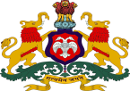**Government of Karnataka**

# Department of Collegiate &Technical Education

**GOVERNMENT POLYTECHNIC**

**CHITRADURGA-577501**

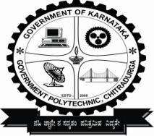**Department of Computer Science & Engineering**

**2023-24**

CERTIFICATE

*This is to certify that* ***SHESHAGIRI S (149CS21046), DIVYA J (149CS21021), DILEEP P (149CS21020), DHANYASHREE (149CS21019)*** have successfully completed the **“CONTINUOUS INTERNAL EVALUATION I , II & III ”** report for the project work titled “INVENTORY MANAGEMENT SYSTEM ” under the course “FULL STACK DEVELOPMENT” of 6th Semester in “Diploma in Computer Science & Engineering”.

**_**

**Cohort owner Sign: Program coordinator Sign:**

**Mrs. Nayana R, BE, M TECH Mr. Suresh T S, BE, M TECH**

**Cohort-owner, CS&E Dept. Program Coordinator, CS&E Dept.**

**Govt. Polytechnic, Chitradurga Govt. Polytechnic, Chitradurga**

**Principal Sign:**

**Mr. B. Ramesh, BE, MTECH,**

**Principal**

**Govt. Polytechnic, Chitradurga**